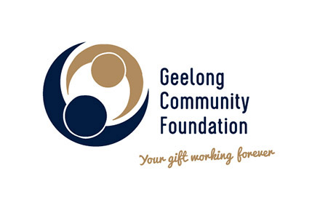
2018 Grant Acquittal Form
(Must be returned by Monday 15 July 2019)

Organisation
Project Title
Contact Name
Phone
Email
Grant Amount
Impact Area

Has your project/program been completed? Please comment.
What was the key purpose and objectives of the project/program?
Did you achieve the above key purpose and objectives?
What needs did your project/program address and have they been achieved?
How many people were assisted by your project/program?
Based on the proposed measurement of outcomes that you identified in your application, were they achieved and what was the result?
What else would you like to tell us about the project/program?
Looking back, is there anything you’d do differently or improve?
How was the Geelong Community Foundation acknowledged by your organisation for receiving the grant? Please outline below and attach examples.

Complete the table below for actual income and expenditure;

Income | $
Grant amount received
Other funding sources and amount

Total Income | $
Expenditure
Breakdown of individual line items such as salaries, equipment, travel, administration etc.

Total Expenditure
Balance Remaining (if any)

Please detail any variances to the budget you provided.

Acquittal
I, the undersigned, being a person duly authorised by (insert organisation
name) _______________________________________________ certify that;
- The above information is true and complete
- The expenditure of the Grant received has been solely on the project for which application was made

Signature ______________________ Position ________________________

Name _________________________ Date ___________________________

Please attach other key project information you would like to share such as evaluation reports (if any) as well as photographs, quotes and stories that the Geelong Community Foundation may use. The provision of such information and images will be taken as permission to publish.

Return information to Gail Rodgers, CEO, Geelong Community Foundation gail@geelongfoundation.org or P O Box 1 Geelong, 3220

