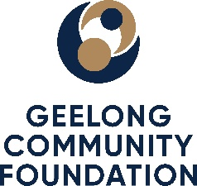
2026 Grant Agreement Terms and Conditions

The grant is being offered based on the following requirements;

- The grant is to be used for the activity as outlined in your organisation’s application and budget, activity and risk plan.

- Grant payment will be made in June 2026 upon receipt of the signed Grant Agreement.

- The grant funding must be used during the period 1 July 2026 to 30 June 2027.

- If at any time, your organisation is unable to deliver the activity as outlined in the application and the budget, activity and risk plan, contact must be made with the Foundation as soon as possible, in order to discuss alternate arrangements or to arrange the return of grant funds.

- Grant recipients are requested to attend the Foundation’s annual Grant Reception evening in May 2026 and host a stall that celebrates your organisation’s work and the activity for which you have received funding. This is a vital opportunity for the Foundation’s donors to meet our grant partners and understand the impact of their support and for all grant partners to network.

- Any changes to the Board/Committee Chair or CEO/Manager during the grant period must be advised to the Foundation upon their commencement in the role.

- Acknowledgement of the funding provided by the Foundation should be made where possible, including but not limited to, recognition via website, newsletters, annual report, media release and physical signage.

- The Foundation requires grant recipients to share stories and photos that demonstrate the progress, key milestones and impact of the activity throughout the grant implementation period. These can be emailed to Charlotte Walker at grants@geelongfoundation.org and will be used by the Foundation for media, newsletter and donor engagement activities. Further, a representative of the Foundation may contact your organisation to request stories and photos throughout the grant implementation period.

- A representative of the Foundation may contact your organisation during the grant implementation period to discuss how your activity is progressing, including to arrange site visits.

- A grant acquittal and final report outlining how the activity was delivered and the impact of the activity is required to be submitted by no later than 31 July 2027.

