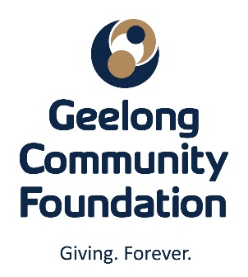
2021 SCHOLARSHIP
APPLICATION FORM

General Education Scholarship $250-$1,000
Tom Cleary Memorial Scholarship $1,000
Rural Education and Retraining Scholarship up to $1,000

Please tick the scholarship/s you wish to apply for. You may apply for all scholarships if you meet the criteria.

General Information:
Full name ____________________________________________________________________
Address ____________________________________________________________________
Telephone _____________________ Email ________________________________________
Date of Birth ____ /____ /______ Male Female
School attended ______________________________________________________________
Last year attended ________________________________________________________________
Qualifications and awards received ___________________________________________________
______________________________________________________________________________________
Additional requirements/Information:
- 300-word statement discussing your goals and career aspirations.
- Other relevant information can be supplied at the discretion of the applicant.
Closing Date: All Scholarship applications close 10th May 2021
After assessing the written applications, a shortlist of candidates will be provided to the Selection Panel and successful applicants will be contacted for interview. The decision of the Selection Panel is final, and no correspondence will be entered into.

Please email Application Form and statement to gail@geelongfoundation.org or post to:
Ms Gail Rodgers
Chief Executive Officer
Geelong Community Foundation
PO Box 1 GEELONG VIC 3220

Note: Applicants must reside in the Geelong region which refers to the City of Greater Geelong, the Surf Coast Shire, the Borough of Queenscliffe and the Southern part of the Golden Plains Shire.

